PERSONALITY ANLYSIS FOR GAME SUGGESTIONS

Mohamed Niyas R

Abstract

Recommended systems have emerged recently in many aspects due to enormous amount of information or items existed in e-commerce or social network services. Users find it convenient if the service can recommend interesting items to them automatically. Past systems adopted users' preference or social connections for such recommendation. In this work, we will try to identify a game player's personality traits and use them to recommend games that may be interested by the player. The personality traits of a player is identified by applying a sentimental analysis and machine learning on textual contents related to the player. The same process is also applied on the comments of the games to identified the personality traits of games.

Introduction

The world of video games has changed considerably over the recent years. Its diversification has dramatically increased the number of users engaged in online communities of this entertainment area, and consequently, the number and types of games available. This context of information overload underpins the development of recommended systems that could leverage the information that the video game platforms collect, hence following the trend of new games coming out every year. In this work we test the potential of state-of-the-art recommended models based respectively on machine learning(ml),and sentimental analysis. We evaluate our results measuring the ranking accuracy of the recommendation and the diversity/novelty of a recommendation list. The best performing algorithm is Deep NN, the high order interactions are more important than the low order ones for this recommendation task. We also analyze the effect of the sentiment extracted directly from game reviews, and find that it is not as relevant for recommendation as one might expect. We are the first in studying the aforementioned recommended systems over the context of online video game platforms,which could be used as baseline in future works.our motto is to collect all the possible available data of a particular user from all kind of social media platform and we have to apply text mining , sentimental analysis and machine learning so that we can suggest them a most accurate kind of game to them which depends on their mood swing so they will like that game and also they must be satisfied with our job .this could be possible with our improved technology

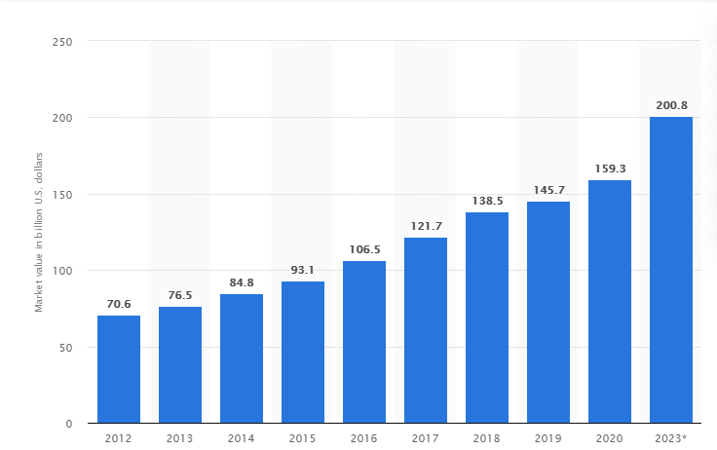Fig 1 evolution of online games

1. sentimental analysis

Sentimental analysis is contextual mining of text which identifies and extracts subjective information in source material, and helping a business to understand the social sentiment of their brand, product or service while monitoring online conversations. However, analysis of social media streams is usually restricted to just basic sentiment analysis and count based metrics. This is akin to just scratching the surface and missing out on those high value insights that are waiting to be discovered With the recent advances in deep learning, the ability of algorithms to analyse text has improved considerably. Creative use of advanced artificial intelligence techniques can be an effective tool for doing in-depth research. Sentiment Analysis is the most common text classification tool that analyses an incoming message and tells whether the underlying sentiment is positive, negative our neutral. The below diagram represents the example output of a sentimental analysis of a user ,in which the values is in negative side which states that he is in negative state of mind .so we could understand their mind and we can also suggest a game to them which they will prefer at that time so user will like that game and also it will get good reviews.

Fig 2 states that the exact output of a sentimental analysis with a dummy data sets .

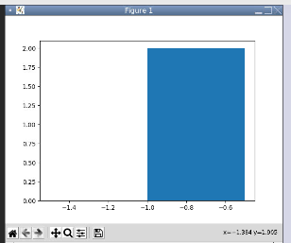

Fig 2 sentimental analysis output

2.1 data mining

Data mining involves exploring and analyzing large blocks of information to glean meaningful patterns and trends. It can be used in a variety of ways, such as database marketing, credit risk management,fraud detection, spam Email filtering, or even to discern the sentiment or opinion of users.

The data mining process breaks down into five steps. First, organizations collect data and load it into their data warehouses. Next, they store and manage the data, either on in-house servers or the cloud. Business analysts, management teams and information technology professionals access the data and determine how they want to organize it. Then, application software sorts the data based on the user's results, and finally, the end-user presents the data in an easy-to-share format, such as a graph or table.

2.2 Data mining in social media

Data mining, as a young field, has been spearheading research and development of methods and algorithms handling huge amounts of data in solving real-world problems. Much like traditional miners extract precious metals from earth and ore, data miners seek to extract meaningful information from a data set that is not readily apparent and not always easily obtainable. With the ubiquitous use of social media via the internet, an unprecedented amount of data is available and of interest to many fields of study including sociology, business, psychology, entertainment, politics, news, and other cultural aspects of societies. Applying data mining to social media can yield interesting perspectives on human behavior and human interaction.

2.3 DATA MINING PROCESS

Social data first needs to be collected and processed. This is data that is publicly available, which may include age, sex, race, geographic location, job profession, schools you’ve attended, languages you speak, friends and connections, networks you belong to, and more.

Then there’s the unstructured content of what you post on social media – like tweets, comments, status updates – which is mainly what businesses, firms, and agencies are looking to mine. So, if your profiles are completely public, just understand this is generally fair game for social media data mining.

Then a variety of data mining techniques are applied. Some techniques may utilize machine learning, some may not. This is all dependent on how deep the “miners” are looking to explore.

Finally, all of this insight needs to be visualized in a way so that it can be interpreted. While there are a variety of data visualization  tools to use, social media analytics often provides its own visualization options.

Conclusion

However these are the advantages of using this technology in future

**1.Increase game Satisfaction**  
Participating in users suggestion programs increases users game satisfaction as employees feel they are positively influencing their organization.

**2.increase in rating**

**it will increase the ratings of that particular games which was suggested by organization to the user**

****3.Increased positive review****

**Since we are finding what they are liking and we are suggesting them to our users it will probably satisfy them so it leads to a much many more positive reviews.**

**4.Improve Customer Satisfaction**  
Organizations such as Starbucks leverage their employee suggestion program to identify ways to serve their customers better, this leads to improved customer satisfaction.

**5.increase Revenue**.

This leads to increased revenue for your organization.